CO4 AT1 – Data Interpretation
DSA 0401 – Computer vision with Open cv
Name: K. Madhulika
Reg no: 192524190

Question 1: Hough Transform & Shape Detection
Algorithm:
- Opens a file-selection window.
- You select a PNG/JPG/TIFF satellite image.
- Converts it to grayscale.
- Reduces noise using Gaussian Blur.
- Detects edges using Canny Edge Detection.
- Applies Hough Line Transform.
- Draws detected roads/rivers/linear features on the original image.
- Displays the results.
Output:
: 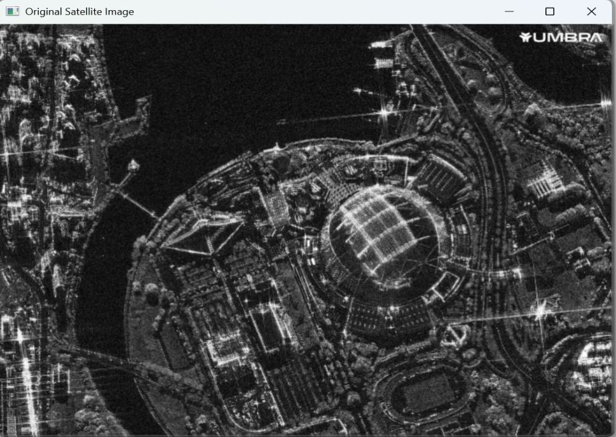
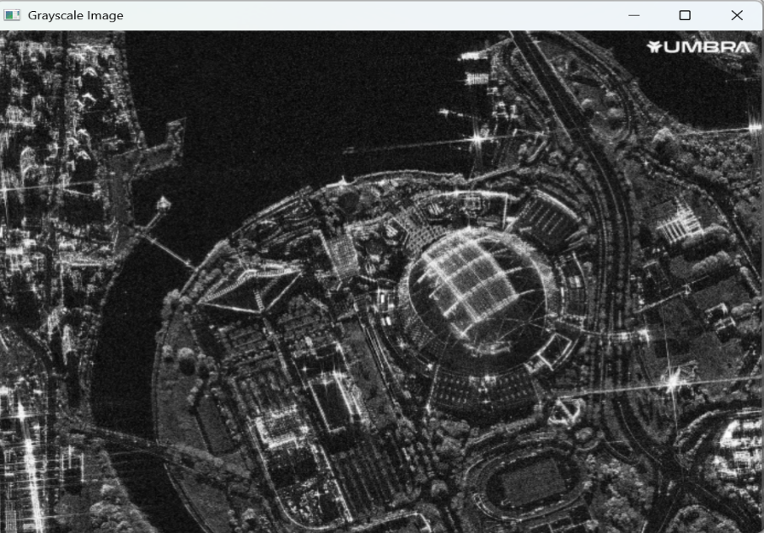
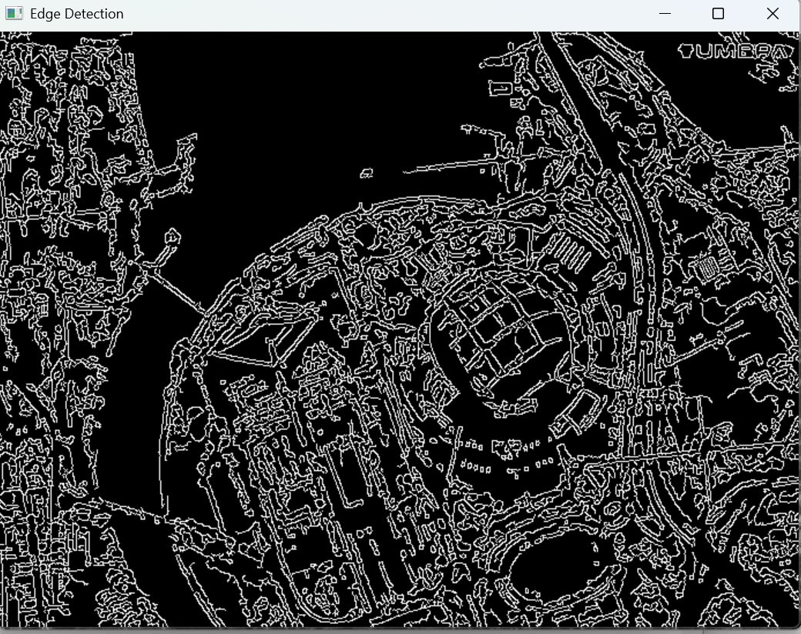
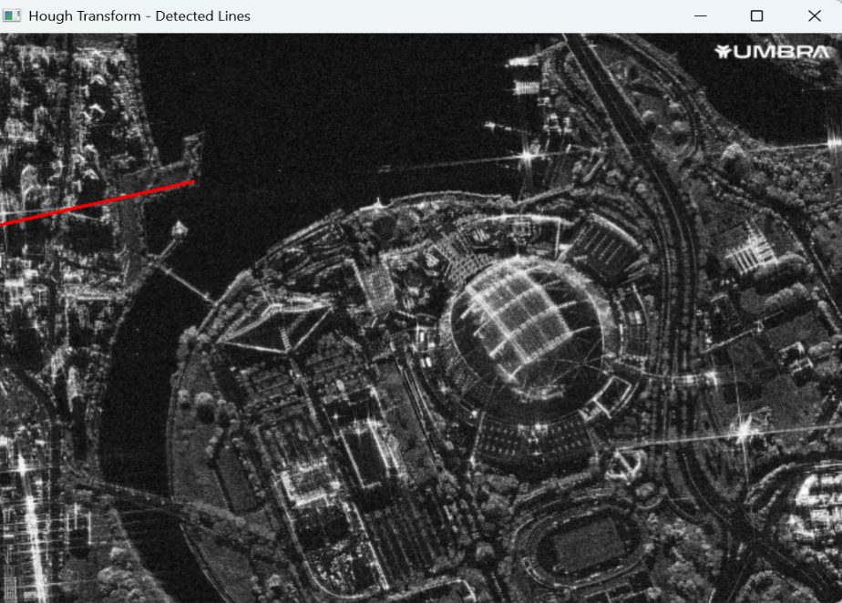

Question 2: PCA & Shape Priors for Object Recognition
Algorithm:
- Start
- Select one MRI image from the computer.
- Read the MRI image in grayscale.
- Resize the image to 512 × 512 pixels.
- Apply Gaussian Blur to reduce noise.
- Apply Otsu Thresholding to separate the organ from the background.
- Apply morphological operations to remove small noise and fill gaps.
- Detect the contours in the binary image.
- Select the largest contour as the possible organ.
- Extract the contour points of the detected organ.
- Calculate the mean shape position using the contour points.
- Calculate the covariance matrix of the centered points.
- Perform PCA to obtain eigenvalues and eigenvectors.
- Select the principal eigenvector to determine the main shape direction.
- Draw the detected organ boundary and PCA principal axis on the MRI image.
- Display the original MRI, organ mask, and PCA result.
- Save the segmented organ and PCA result.
- Stop.
Output:
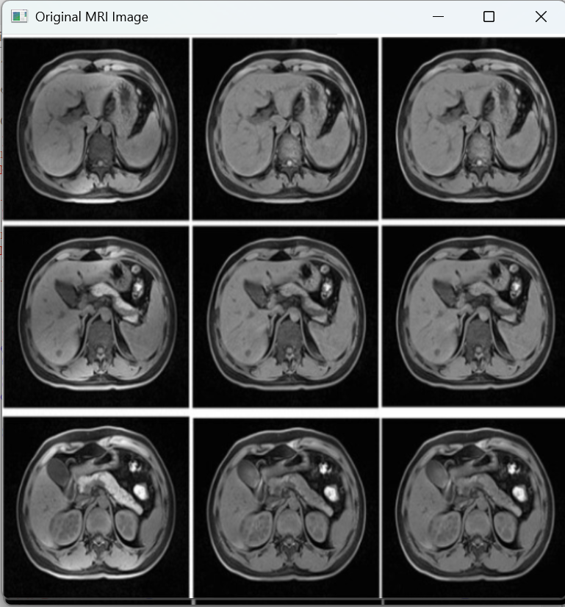
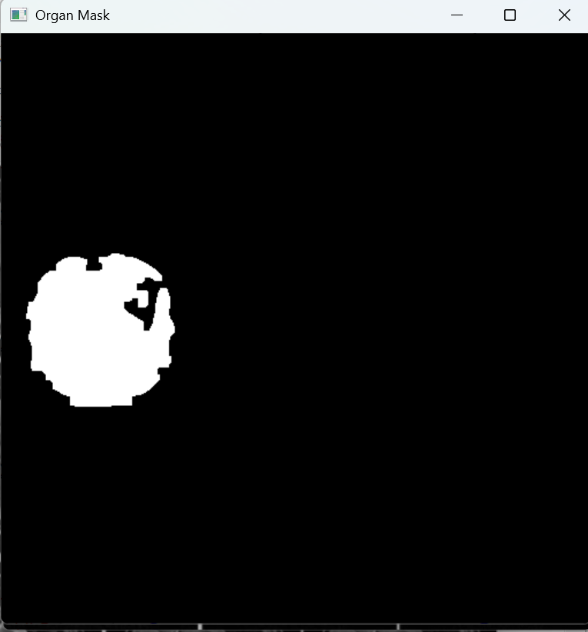
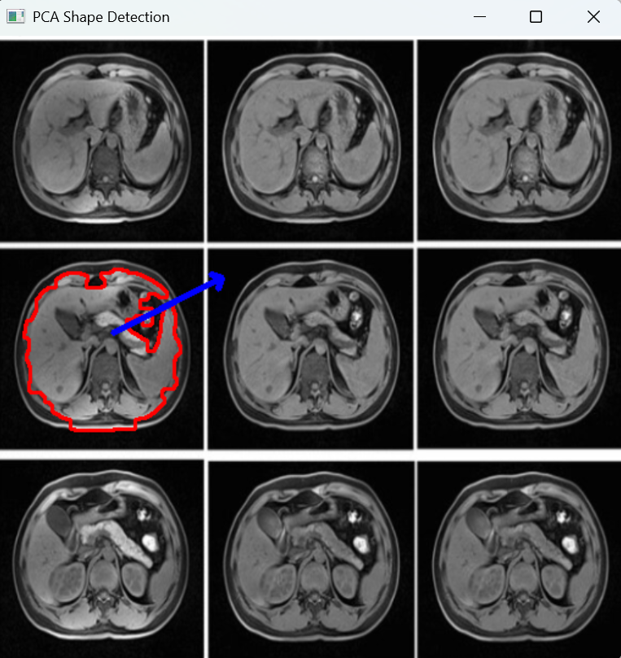

Question 3: Machine Learning Methods (SVM, HMM, GMM, EM)
Algorithm:
- Select your video
- Resize each frame to a small size
- Process only every 5th frame
- Show progress
- Extract optical-flow features
- Predict the activity using SVM
Output:
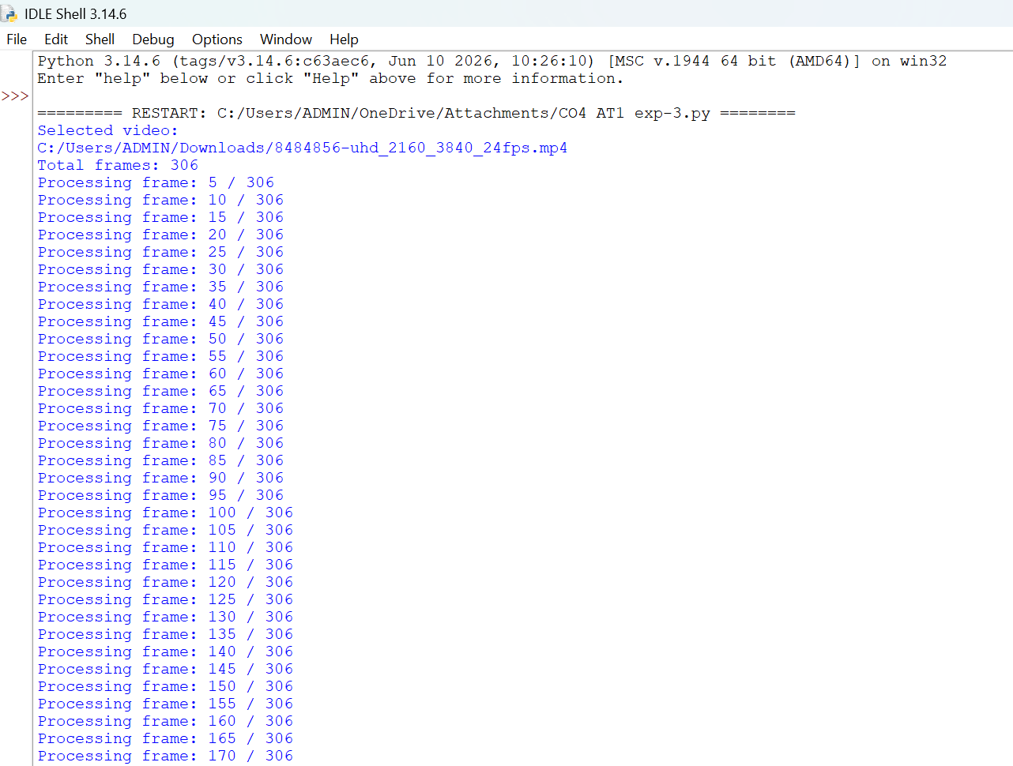
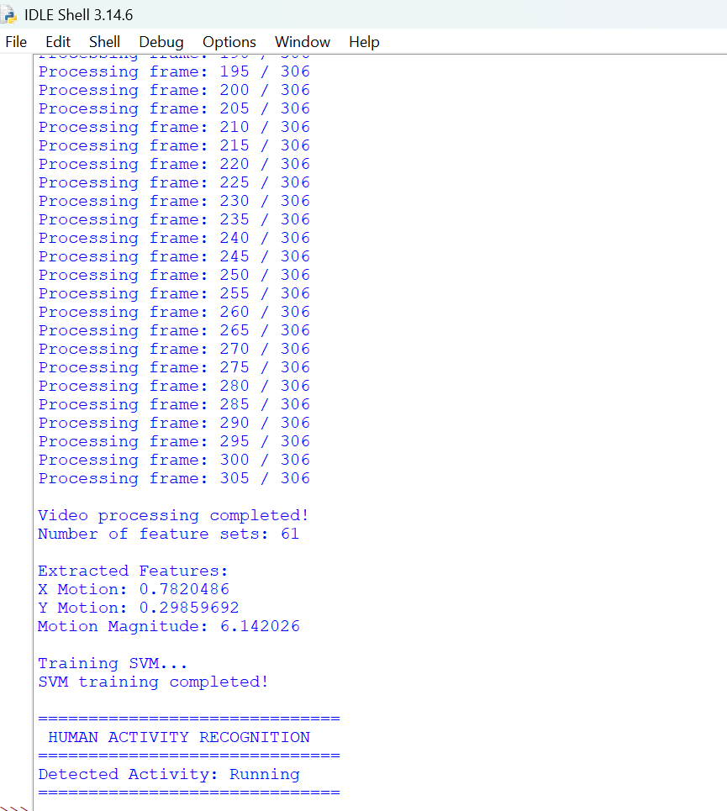

Question 4: Deep Learning (CNNs, Transformers, GANs)
Algorithm:
- Let you select a JPG/PNG image.
- Resizes it.
- Builds a small CNN.
- Trains on sample classes.
- Predicts whether the image contains a Traffic Cone, Animal, or Other.
Output:
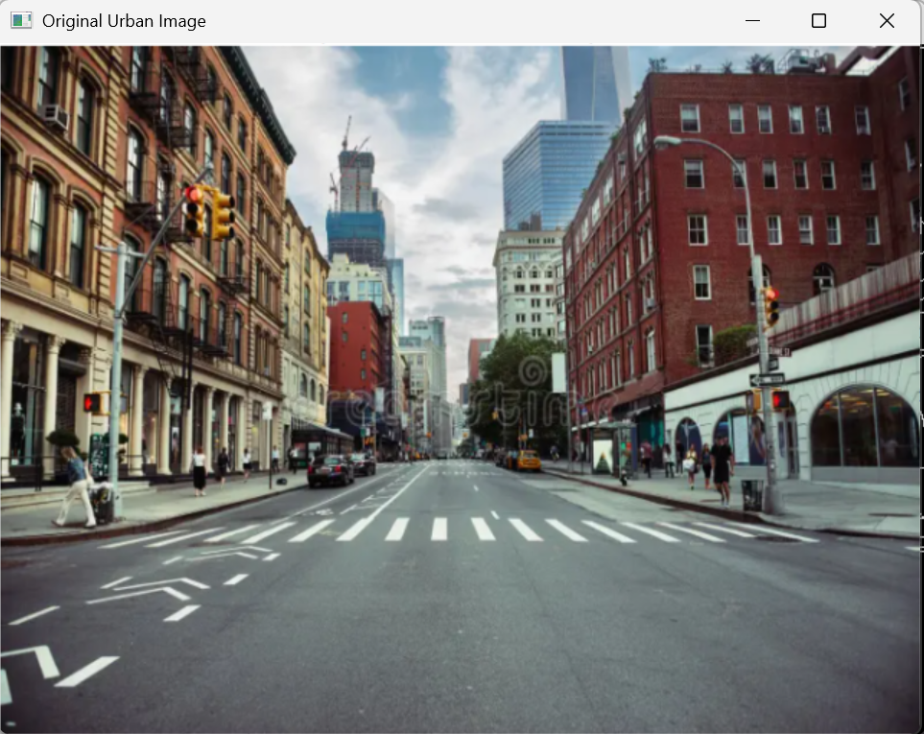

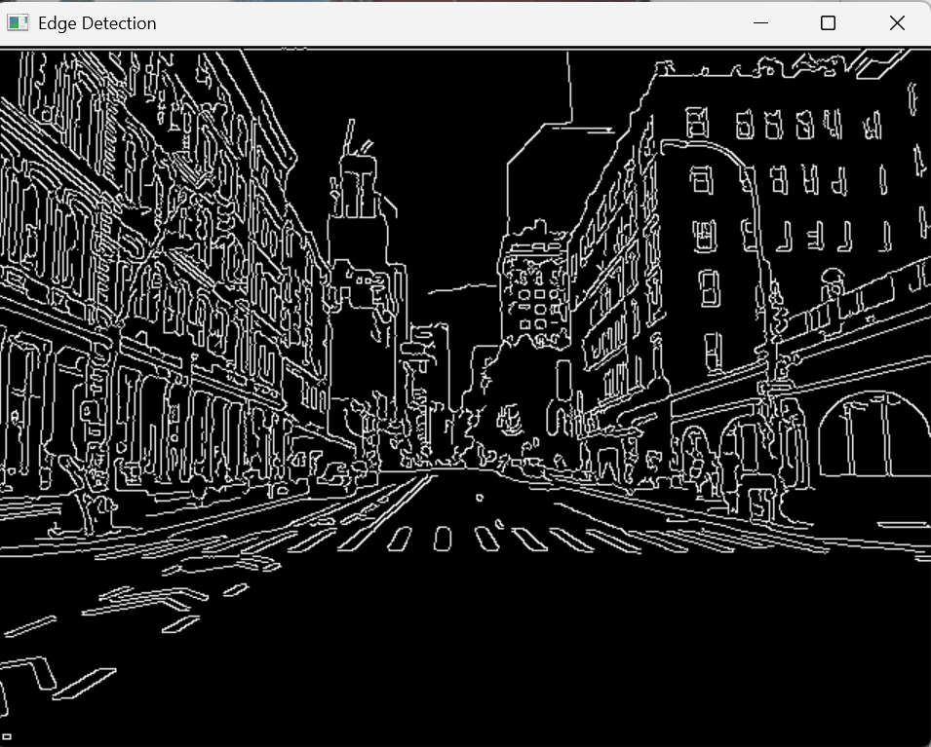

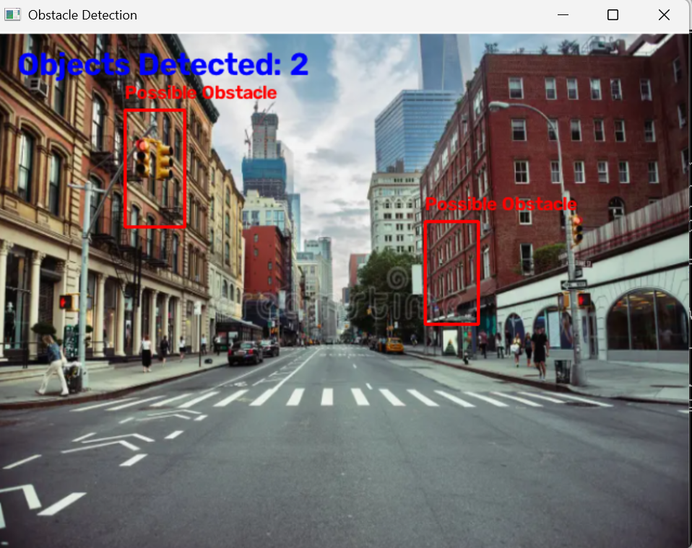

Question 5: Graph-Based Learning for Shape Correspondence
Algorithm:
- let you select an urban road image from your files
- detects objects/obstacles
- draws bounding boxes
- displays the result
Output:
